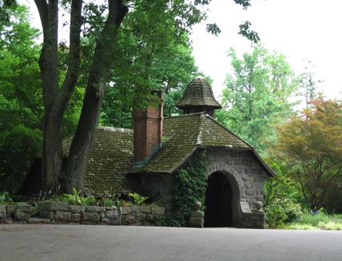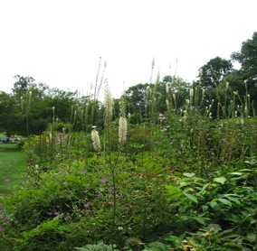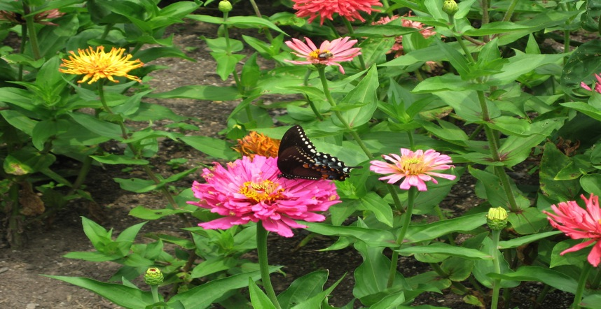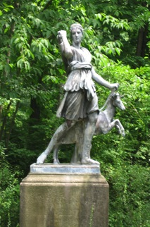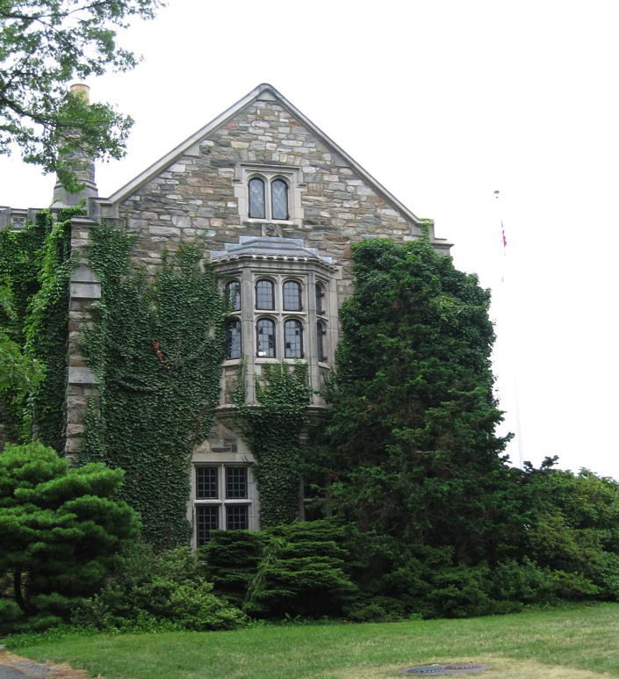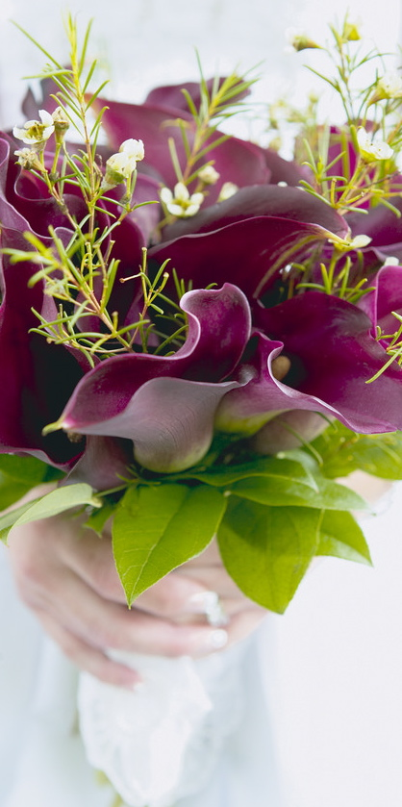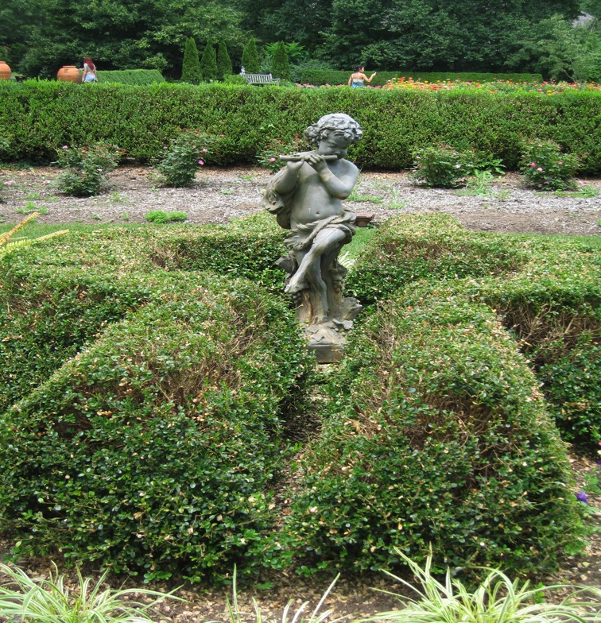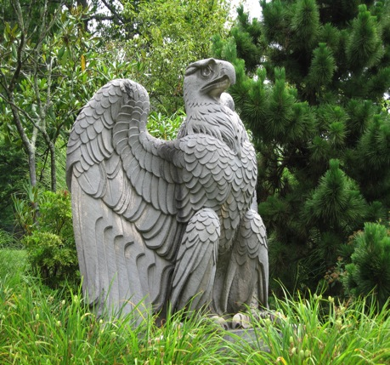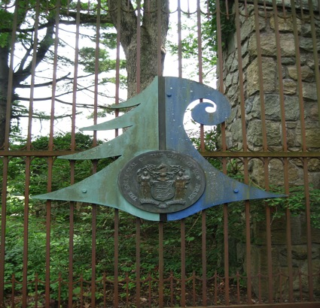

Skylands

New Jersey Botanical Garden

Created by: Lindsey Almeida

2 Morris Road

Ringwood, New Jersey 07456

www.NJBG.org

**Directions:**

**Via I-287 (North or South)**

1. Follow I-287 north or South and exit at Exit 57.
2. After exiting, turn left from I-287 north, or right from I-287 south, following signs for Skyline Drive.
3. Take Skyline Drive up the mountain and back down, about 4.8 miles.
4. At the traffic light (Erskine Road) go straight, and then turn right at the stop sign onto CR-511 (Greenwood Lake Turnpike.)
5. Go about 1.5 miles, taking the second right onto Sloatsburg Road.
6. Go about 2 miles, past Hewitt School (on your right), Carletondale Rd. (on your right), and Margaret King Ave. (on your left).
7. Take the next right onto Morris Road; Skylands is 0.75 miles up Morris Rd., at the top of the hill.

**From NYC (via NJ-4 and NJ-208)**

1. Take the George Washington Bridge to NJ-4 west and follow NJ-4 eight miles through Paramus.
2. Then, take NJ-208 ten miles to I-287 South to exit 57.
3. Then follow directions above.

ACCESSIBILITY

Handicap parking is available in Lots A,  
B & C. Most roads are paved for more information please call:

973-962-9534

Skylands NJBG

**Where history and architecture come together.**

Guided tours of the Skylands Manor are available on select Sundays, tours last about 45 minutes.

ADMISSIONS:

General: $7

Seniors: $5

Youth: $5

Children: $3

Children under 6 are free

## Skylands Manor

# Beautiful Gardens

EXPLORE AND DISCOVER

Come and explore a New Jersey wonder! Sculptures and flowers fill 96 acres and surrounded by 100 acres of woodlands. A perfect place for a class fieldtrip or a family hike. Rediscover your love for nature by wandering through the 13 different flower gardens or walking through the lush surrounding forests on marked trails.

### Skylands Manor

Set back in the beautiful woods of Ringwood, Skylands Manor was designed in the mid-1920’s by an American architect John Russell Pope. Elliot C. Brown, the builder, is also known to have built a country house for Franklin D. Roosevelt and E. Roland Harriman.

This tutor style castle boasts native granite walls, which, along with the rest of the stone used on the Manor were quarried on site. The castle, designed in the Tutor style, was intentionally designed to make it look centuries old.

The original owners, were involved in horticulture, and dotted the sprawling lawns with different styles of beautiful gardens. Sculptures have been added through the years to add a bit of artistic visual interest in the already stunning landscape.